Day 15
Task 1: 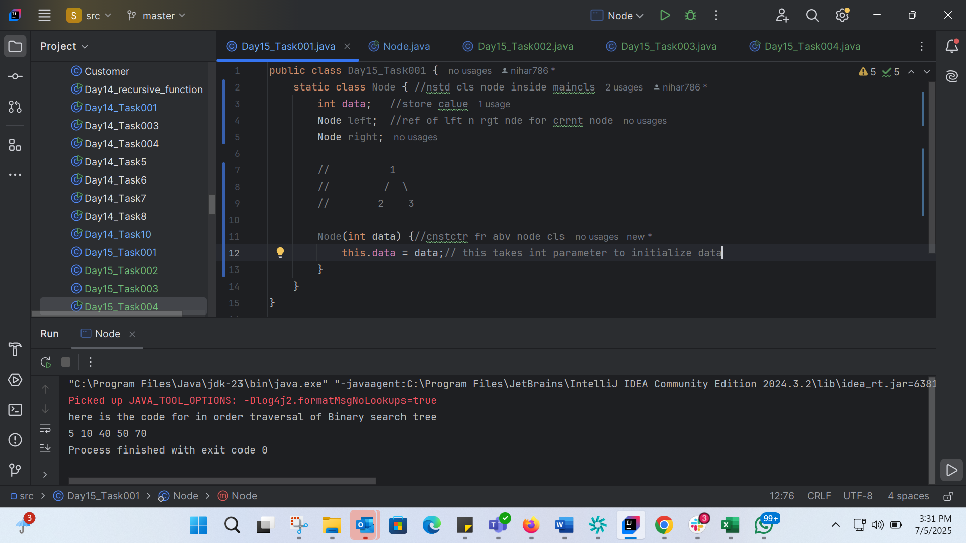

Task 2: 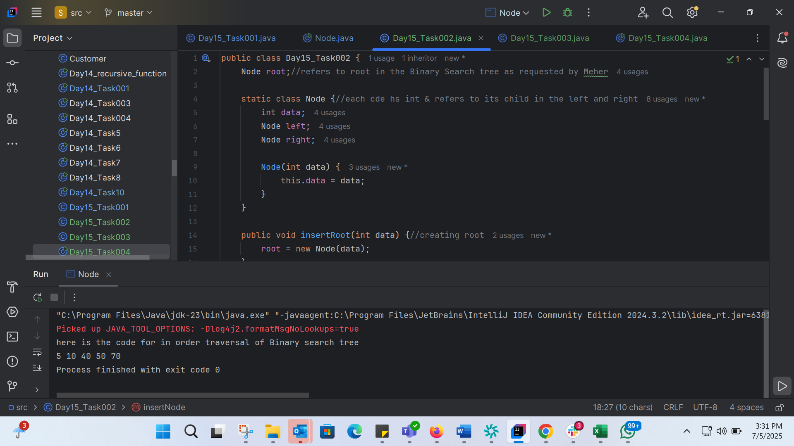
Task 3: 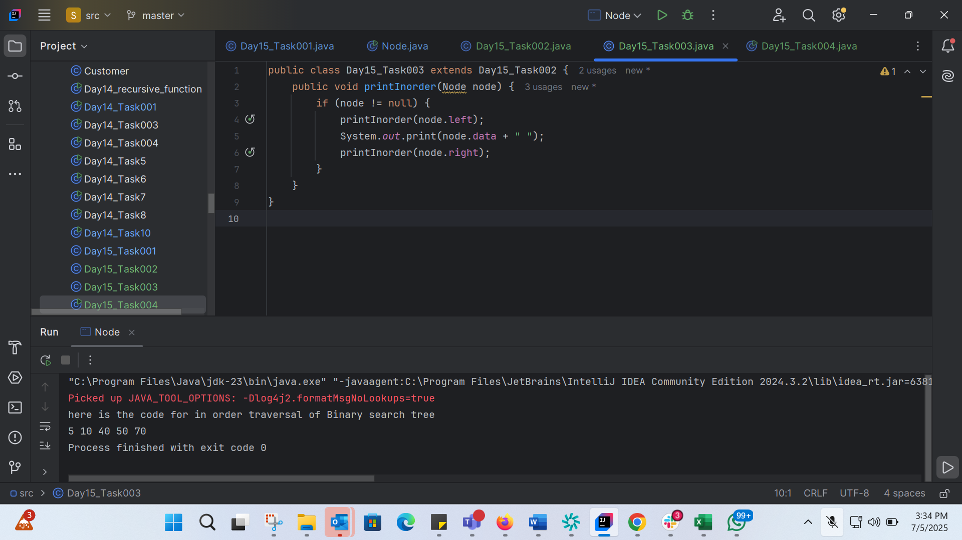
Task 4: 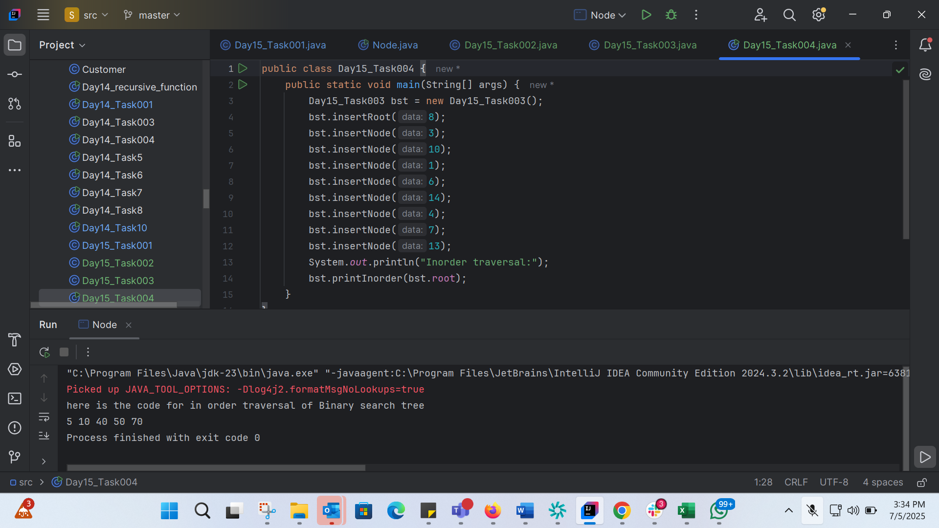

Code by Meher:
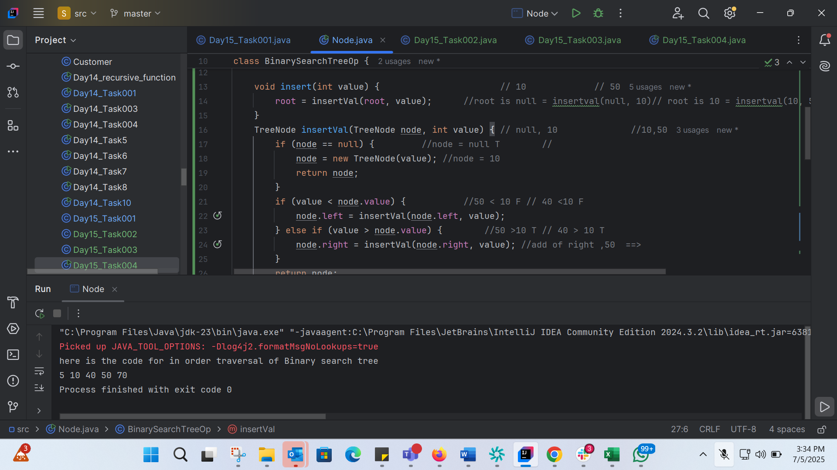
class TreeNode {
int value;
TreeNode left, right;
TreeNode(int item) {
value = item;
left = right = null;
}
}
class BinarySearchTreeOp {
TreeNode root;
void insert(int value) { // 10 // 50
root = insertVal(root, value); //root is null = insertval(null, 10)// root is 10 = insertval(10, 50)//root is 50 = /// 10, 40
}
TreeNode insertVal(TreeNode node, int value) { // null, 10 //10,50
if (node == null) { //node = null T //
node = new TreeNode(value); //node = 10
return node;
}
if (value < node.value) { //50 < 10 F // 40 <10 F
node.left = insertVal(node.left, value);
} else if (value > node.value) { //50 >10 T // 40 > 10 T
node.right = insertVal(node.right, value); //add of right ,50 ==>
}
return node;
}
void inorder() {
inorderVal(root);
}
void inorderVal(TreeNode node) {
if (node != null) {
inorderVal(node.left);
System.out.print(node.value + " ");
inorderVal(node.right);
}
}
}
public class Node {
public static void main(String[] args) {
BinarySearchTreeOp bstobj = new BinarySearchTreeOp();
bstobj.insert(10); //===> root
bstobj.insert(50);
bstobj.insert(40);
bstobj.insert(70);
bstobj.insert(5);
System.out.println("here is the code for in order traversal of Binary search tree ");
bstobj.inorder();
}
}

Task 5:
Applications of Trees
1. File System Organization: Java's File class uses a tree-like structure to represent the directory hierarchy of a file system.
2. XML and JSON Parsing: Java's XML and JSON parsing libraries, such as DOM and Jackson, use trees to represent the structure of XML and JSON documents.
3. Database Query Optimization: Java's database query optimization libraries, such as Hibernate, use trees to represent query plans and optimize database queries.
4. GUI Component Layout: Java's Swing library uses trees to represent the component hierarchy of a GUI application.
5. Game Development: Java's game development libraries, such as libGDX, use trees to represent game scenes, menus, and other game-related data structures.

Task 6:
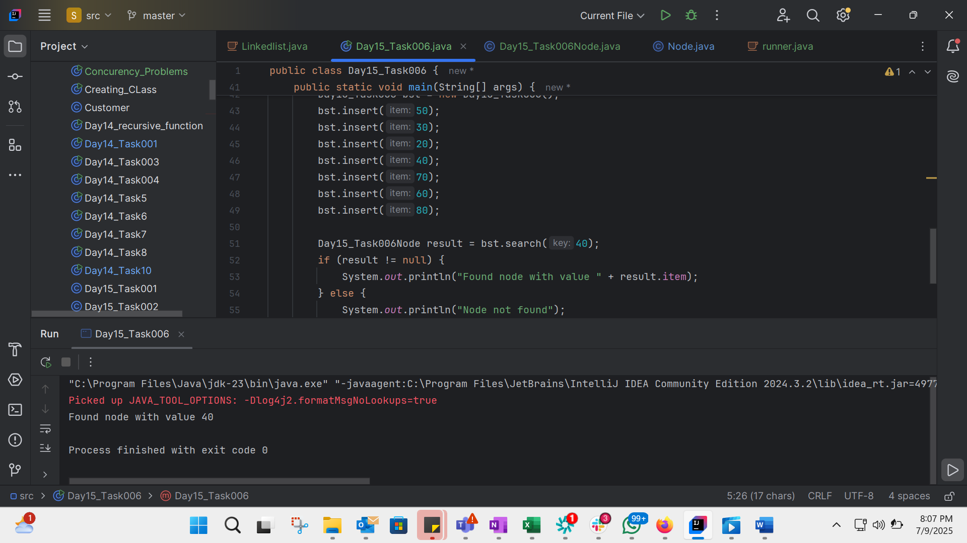
public class Day15_Task006 {
Day15_Task006Node root;
public Day15_Task006() {
this.root = null;
}
public void insert(int item) {
root = insertNode(root, item);
}
private Day15_Task006Node insertNode(Day15_Task006Node root, int item) {
if (root == null) {
root = new Day15_Task006Node(item);
return root;
}
if (item < root.item) {
root.left = insertNode(root.left, item);
} else if (item > root.item) {
root.right = insertNode(root.right, item);
}
return root;
}
public Day15_Task006Node search(int key) {
Day15_Task006Node current = root;
while (current != null) {
if (key == current.item) {
return current;
} else if (key < current.item) {
current = current.left;
} else {
current = current.right;
}
}
return null;
}
public static void main(String[] args) {
Day15_Task006 bst = new Day15_Task006();
bst.insert(50);
bst.insert(30);
bst.insert(20);
bst.insert(40);
bst.insert(70);
bst.insert(60);
bst.insert(80);
Day15_Task006Node result = bst.search(40);
if (result != null) {
System.out.println("Found node with value " + result.item);
} else {
System.out.println("Node not found");
}
}
}

class Day15_Task006Node {
int item;
Day15_Task006Node left, right;
Day15_Task006Node(int item) {
this.item = item;
left = right = null;
}
}

Task 7:
Types of binary trees:
1. Full Binary Tree: A full binary tree is a tree in which every node has either 0 or 2 children. In other words, every node is either a leaf node or has two children.
2. Empty Binary Tree: An empty binary tree is a tree that has no nodes.
3. Complete Binary Tree: A complete binary tree is a tree in which every level is fully filled except for the last level, which is filled from left to right.
4. Perfect Binary Tree: A perfect binary tree is a tree in which all interior nodes have two children and all leaves are at the same level.
5. Balanced Binary Tree: A balanced binary tree is a tree in which the height of the left and right subtrees of every node differs by at most 1.
6. Degenerate Binary Tree: A degenerate binary tree is a tree in which every node has only one child, effectively forming a linked list.
7. Skewed Binary Tree: A skewed binary tree is a tree in which all nodes have only one child, either left or right.
Task 8:
Applications of Graphs
1. Social Network Analysis: Graphs can be used to represent social networks, where nodes represent individuals and edges represent relationships between them.
2. Web Page Ranking: Graphs can be used to represent the web, where nodes represent web pages and edges represent links between them.
3. Route Planning: Graphs can be used to represent road networks, where nodes represent intersections and edges represent roads between them.
4. Network Topology: Graphs can be used to represent computer networks, where nodes represent devices and edges represent connections between them.
5. Recommendation Systems: Graphs can be used to represent relationships between users and items, where nodes represent users or items and edges represent interactions between them.
6. Traffic Simulation: Graphs can be used to simulate traffic flow, where nodes represent intersections and edges represent roads between them.
7. Scheduling: Graphs can be used to represent scheduling problems, where nodes represent tasks and edges represent dependencies between them.

Task 9:
Types of Graphs:
1. Directed Graph (Digraph): A graph in which edges have direction, representing a one-way relationship between nodes.
2. Undirected Graph: A graph in which edges do not have direction, representing a two-way relationship between nodes.
3. Weighted Graph: A graph in which edges have weights or labels, representing the strength or cost of the relationship between nodes.
4. Unweighted Graph: A graph in which edges do not have weights or labels.
5. Cyclic Graph: A graph that contains at least one cycle, where a cycle is a path that starts and ends at the same node.
6. Acyclic Graph: A graph that does not contain any cycles.
7. Simple Graph: A graph that does not contain multiple edges between any two nodes.
8. Multigraph: A graph that allows multiple edges between any two nodes.
9. Complete Graph: A graph in which every node is connected to every other node.
10. Bipartite Graph: A graph whose nodes can be divided into two disjoint sets such that every edge connects a node from one set to a node from the other set.

TASK 10:
class Day15_Task009 {
class Edge {
int src, dest;
public String toString() {
return src + " - " + dest;
}
}
int vertices, edges;
Edge[] edge;
Day15_Task009(int vertices, int edges) {
this.vertices = vertices;
this.edges = edges;
edge = new Edge[edges];
for (int i = 0; i < edges; i++) {
edge[i] = new Edge();
}
}
public static void main(String[] args) {
int noVertices = 5;
int noEdges = 8;
Day15_Task009 gObj = new Day15_Task009(noVertices, noEdges);
// Initialize edges
gObj.edge[0].src = 1;
gObj.edge[0].dest = 2;
gObj.edge[1].src = 1;
gObj.edge[1].dest = 3;
gObj.edge[2].src = 1;
gObj.edge[2].dest = 4;
gObj.edge[3].src = 2;
gObj.edge[3].dest = 4;
gObj.edge[4].src = 2;
gObj.edge[4].dest = 5;
gObj.edge[5].src = 3;
gObj.edge[5].dest = 4;
gObj.edge[6].src = 3;
gObj.edge[6].dest = 5;
gObj.edge[7].src = 4;
gObj.edge[7].dest = 5;
// Print edges
System.out.println("Graph Edges:");
for (int i = 0; i < noEdges; i++) {
System.out.println(gObj.edge[i]);
}
}
}

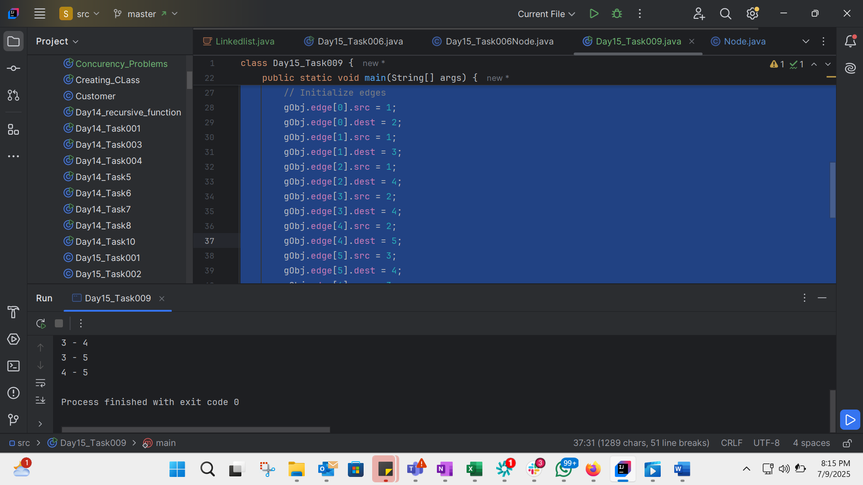
Home TasK:
Write a recursive function to count the digits of a positive integer (do also for sum of digits)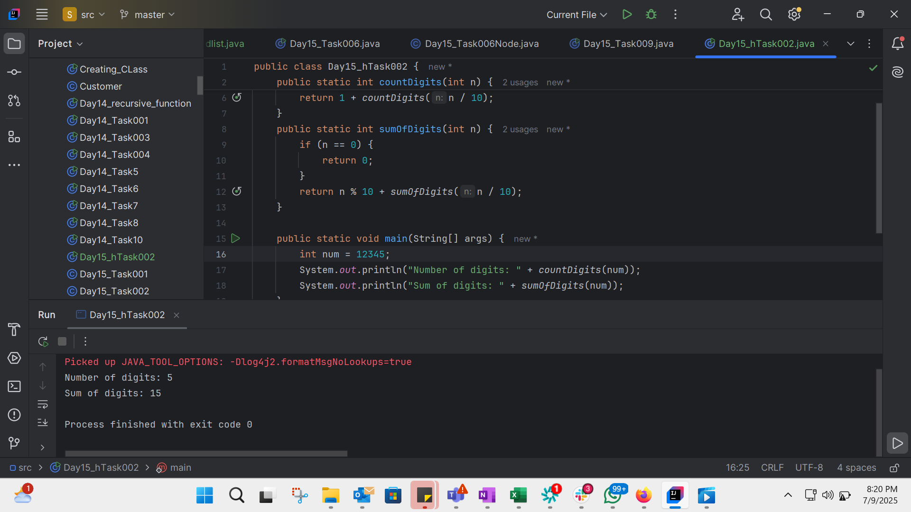
public class Day15_hTask003 {
public static String reverseString(String str) {
if (str.isEmpty()) {
return str;
}
return reverseString(str.substring(1)) + str.charAt(0);
}
public static void main(String[] args) {
String str = "Hello World";
System.out.println("Original string: " + str);
System.out.println("Reversed string: " + reverseString(str));
}
}

Home task 3: Write a recursive function to reverse a null-terminated string
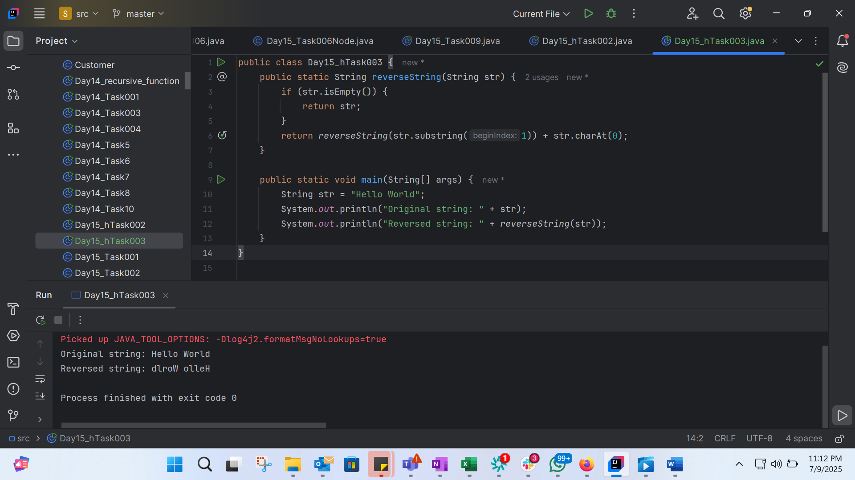

Home task 4: Write a recursive function to convert a decimal number to binary 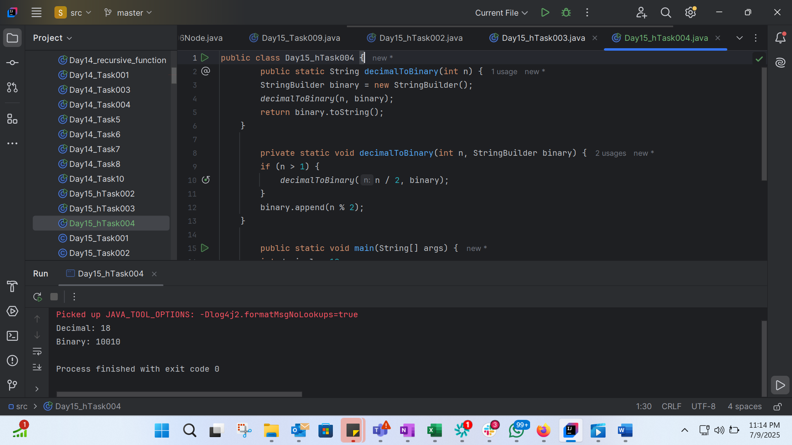
public class Day15_hTask004 {
public static String decimalToBinary(int n) {
StringBuilder binary = new StringBuilder();
decimalToBinary(n, binary);
return binary.toString();
}
private static void decimalToBinary(int n, StringBuilder binary) {
if (n > 1) {
decimalToBinary(n / 2, binary);
}
binary.append(n % 2);
}
public static void main(String[] args) {
int decimal = 18;
System.out.println("Decimal: " + decimal);
System.out.println("Binary: " + decimalToBinary(decimal));
}
}

